Spring Cloud中使用zookeeper作为服务注册中心

- windows环境下安装zookeeper

下载
zookeeper官网下载地址
http://mirrors.hust.edu.cn/apache/zookeeper/zookeeper-3.4.10/
解压
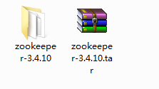

启动
命令：zkService.cmd
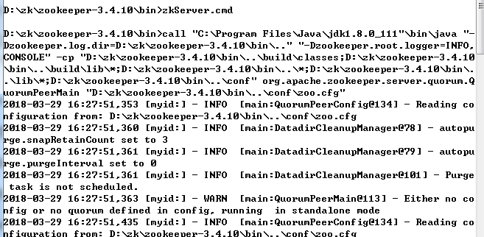

查看节点
另开一个窗口，启动zk客户端：zkCli -server 127.0.0.1:2181
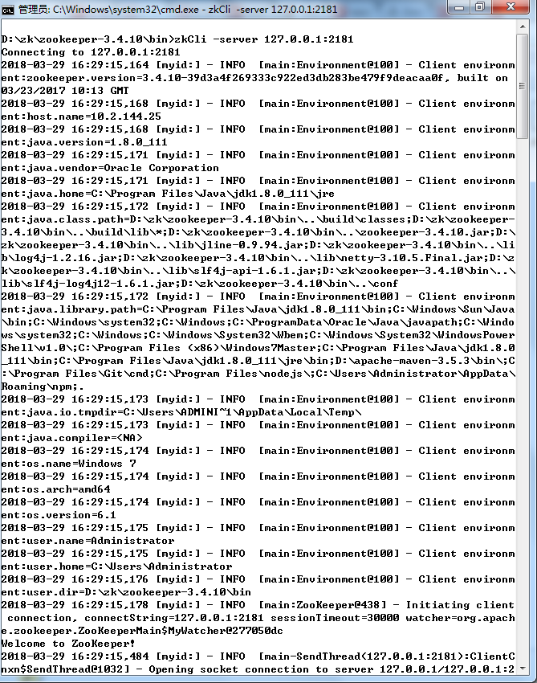
查看节点：ls /services
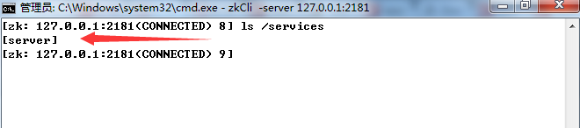

- 创建Spring Cloud工程，并在zookeeper中注册

maven依赖
<dependency>
<groupId>org.springframework.cloud</groupId>
<artifactId>spring-cloud-starter-zookeeper-discovery</artifactId>
</dependency>

启动类
@SpringBootApplication
@EnableDiscoveryClient
public class ZkDemoApplication {

public static void main(String[] args) {
SpringApplication.run(ZkDemoApplication.class, args);
}
}

配置文件application.properties

## 配置应用名称
spring.application.name=spring-cloud-zookeeper-client-app
## 配置服务端口
server.port=8080
## 关闭安全控制
management.security.enabled=false
## 配置zookeeper地址
spring.cloud.zookeeper.connect-string=127.0.0.1:2181

使用DiscoveryClient获取注册服务列表API
@RestController
@RequestMapping("/zookeeper")
public class ZookeeperController {

@Value("${spring.application.name}")
private String instanceName;

private final DiscoveryClient discoveryClient;

@Autowired
public ZookeeperController(DiscoveryClient discoveryClient) {
this.discoveryClient = discoveryClient;
}

@GetMapping
public String hello() {
return "Hello,Zookeeper.";
}

@GetMapping("/services")
public List<String> serviceUrl() {
List<ServiceInstance> list = discoveryClient.getInstances(instanceName);
List<String> services = new ArrayList<>();
if (list != null && list.size() > 0 ) {
list.forEach(serviceInstance -> {
services.add(serviceInstance.getUri().toString());
});
}
return services;
}
}

- 查看注册状态

在zookeeper中查看节点信息
命令：ls /services
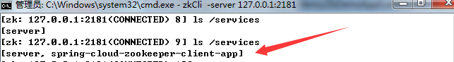

访问接口查看节点信息
地址:http://localhost:8080/zookeeper/services

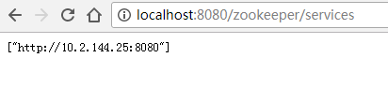
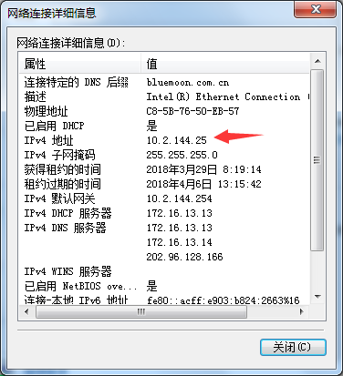

代码下载地址：
https://github.com/zhu-wen/spring-clould/tree/master/spring-cloud-zookeeper/zk-demo

